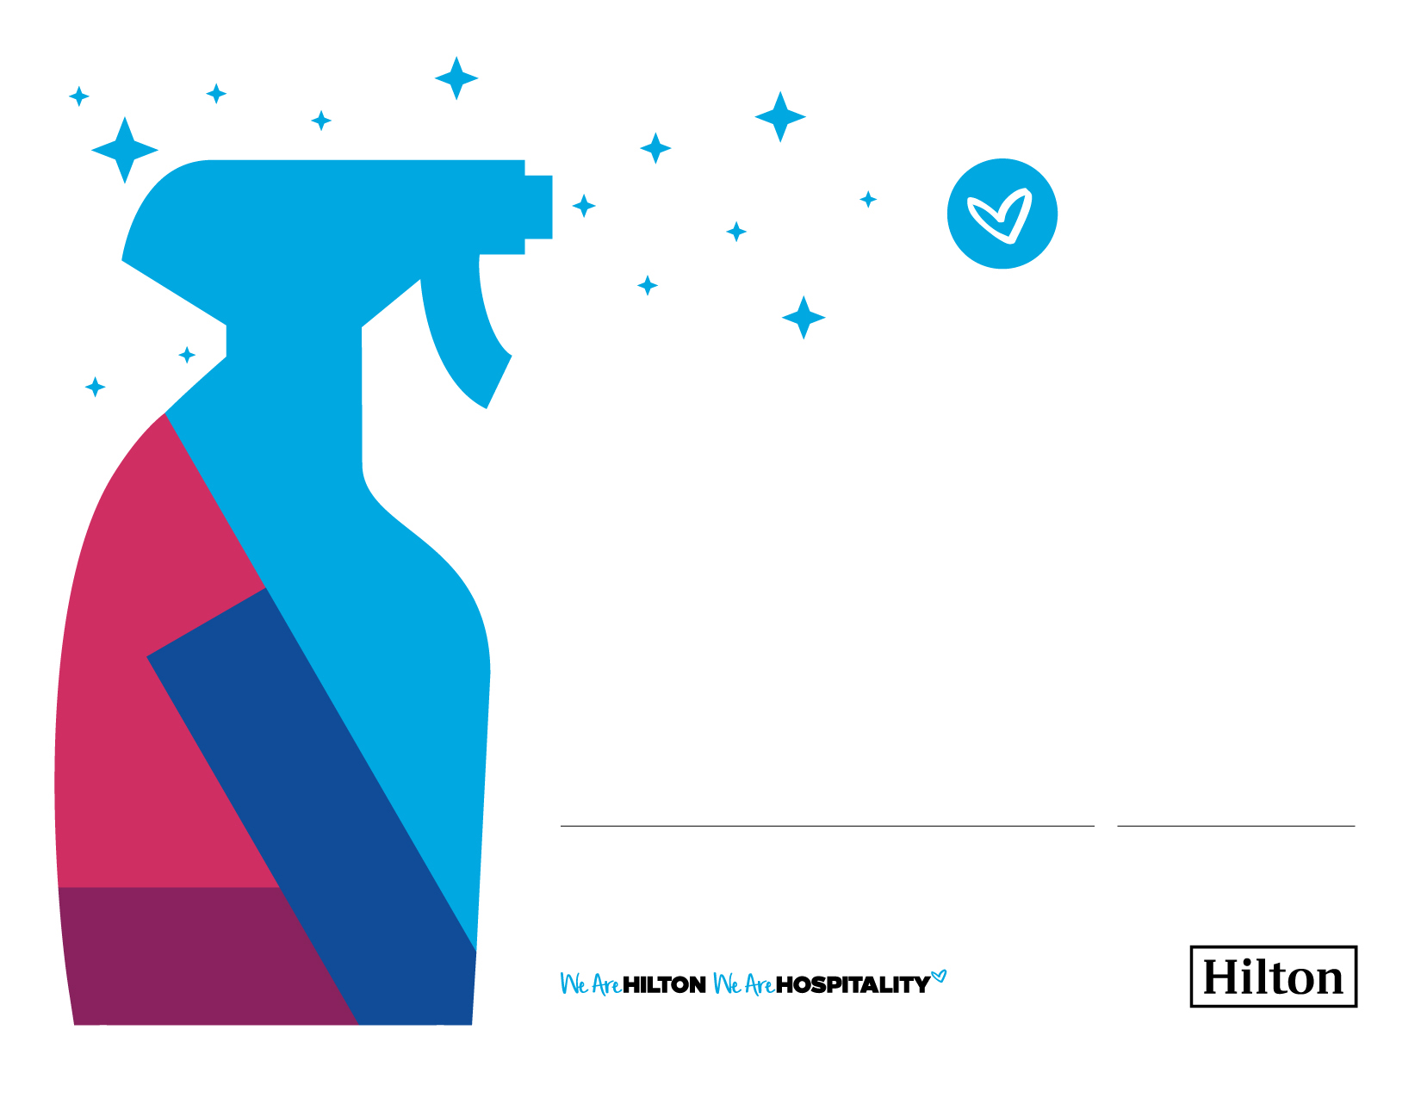

DATE

International

Housekeeping

Week 2018

September 9–15

CERTIFICATE OF RECOGNITION

Team Member Name

Type in a personal note of appreciation here. Be specific. All content is customizable, including language. Simply type over the message. You have up four lines to type your message. Type in a personal note of appreciation here. Simply type over the message.

PRESENTED BY